PROGRAM 6

A)Write a Python program to illustrate Linear Plotting using Matplotlib.

SOURCE CODE

import matplotlib.pyplot as plt

# Hypothetical data: Run rate in an T20 cricket match
overs = [0,1,2,3,4,5,6,7,8,9,10,11,12,13,14,15,16,17,18,19,20]
runs_scored = [0,7,12,20,39,49,61,83,86,97,113,116,123,137,145,163,172,192,198,198,203]

# Create a linear plot
plt.plot(overs, runs_scored)

# Add labels and title
plt.xlabel('Overs')
plt.ylabel('Runs scored')
plt.title('Run scoring in an T20 Cricket Match')

# Display the plot
plt.grid(True)
plt.show()

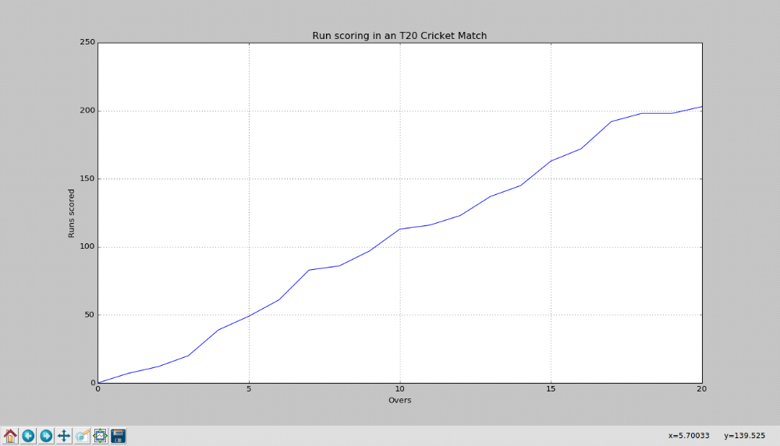

B)Write a Python program to illustrate liner plotting with line formatting using Matplotlib.

SOURCE CODE

import matplotlib.pyplot as plt

# Hypothetical data: Run rate in an T20 cricket match
overs = [0,1,2,3,4,5,6,7,8,9,10,11,12,13,14,15,16,17,18,19,20]
runs_scored = [0,7,12,20,39,49,61,83,86,97,113,116,123,137,145,163,172,192,198,198,203]

# Create a linear plot
plt.plot(overs, runs_scored, marker='X', linestyle='dashed',color='red', linewidth=2, markerfacecolor='blue', markersize=8)

# Add labels and title
plt.xlabel('Overs', color = 'green')
plt.ylabel('Runs scored')
plt.title('Run scoring in an T20 Cricket Match')

# Display the plot
plt.grid(True)
plt.show()

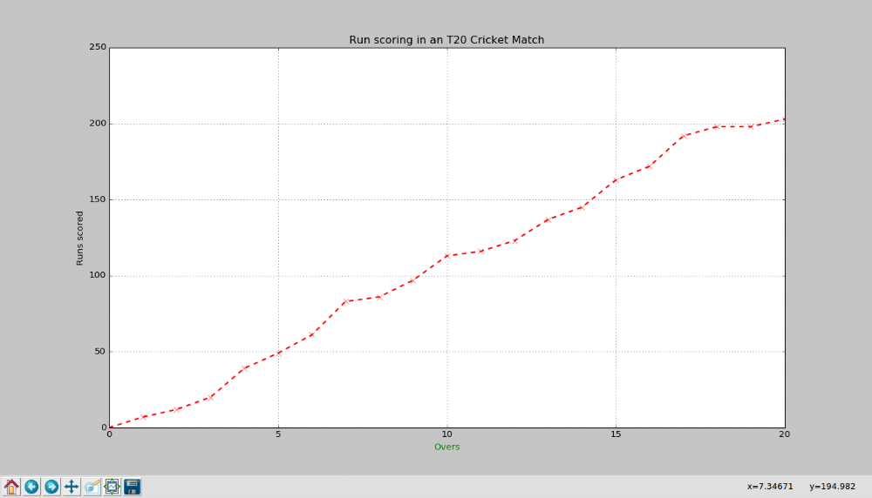

PROGRAM 7

Write a Python program which explains uses of customizing seaborn plots with Aesthetic functions

SOURCE CODE

import numpy as np
import matplotlib.pyplot as plt
import seaborn as sns

def sinplot(n=10):
x = np.linspace(0, 14, 100)
for i in range(1, n + 1):
plt.plot(x, np.sin(x + i * .5) * (n + 2 - i))

sns.set_theme()
#sns.set_context("talk")
sns.set_context("notebook", font_scale=1.5, rc={"lines.linewidth": 2.5})

sinplot()
plt.title('Seaborn plots with Aesthetic functions')
plt.show()

